NCLC EXAM TABLETS
CP20 Android Tablet
Proctor Setup and Use Instructions v231028
As an NCLC Exam Proctor, if you are using the NCLC supplied tablets for the proctored online testing then you’ll receive them already setup and configured for use as a dedicated testing device, including having the homepage of the browser set to the testing site of https://LaserTraining.learn.trakstar.com.
However, you’ll still need to configure them for the connection to your internet router. Please don’t change the homepage of the browser which is set to the NCLC testing page so that it automatically goes there when they open the browser.
To connect the tablet to your router, follow these steps:
Turn on tablet / Settings / Network & Internet / Wi-Fi / Choose your router SSID / Enter Password
Allow it to remember your connection and connect automatically.
Screenshots for the steps listed above are:
Turn on tablet/ Settings (Power button is the bottom one on left side of tablet – press & hold)
When the screen just comes up blue with no icons, then just “swipe up” to open it.
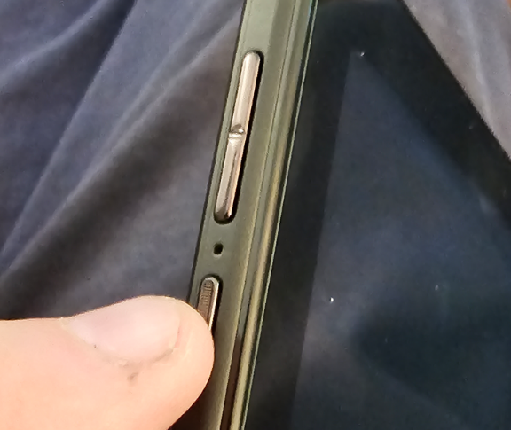
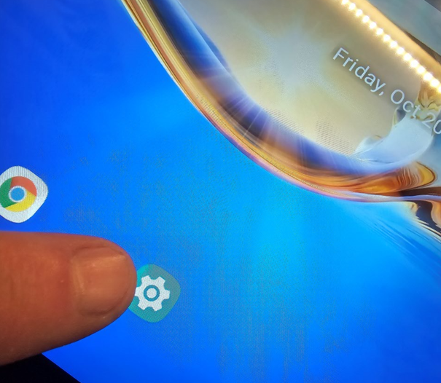
Network & Internet / Wi-Fi
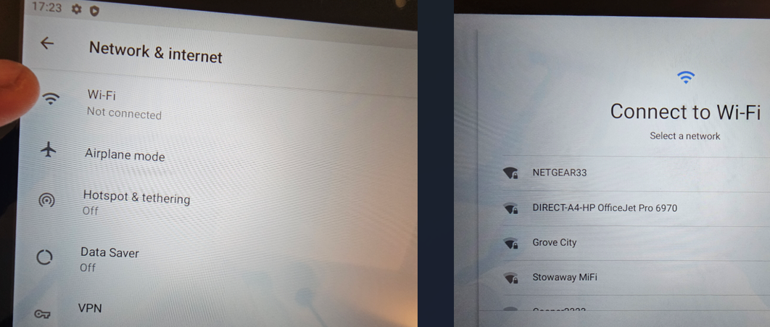
Choose your own router SSID for the connection.
Enter your password, then “Connect”.
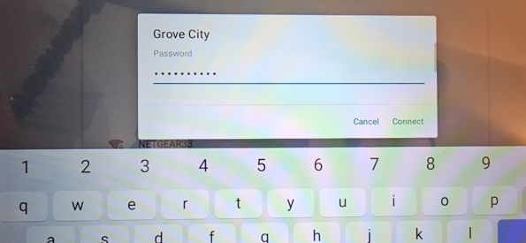
When you want to close windows just hit the “square” button on the lower menu bar:
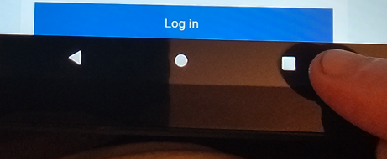
That will “minimize and float” that application, then just “swipe up” to close it (like an iPad)
Now open the Internet Browser from the homepage to open it, and it should take you to the LaserTraining.learn.trakstar.com homepage:
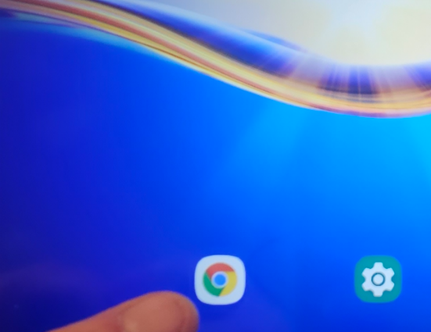
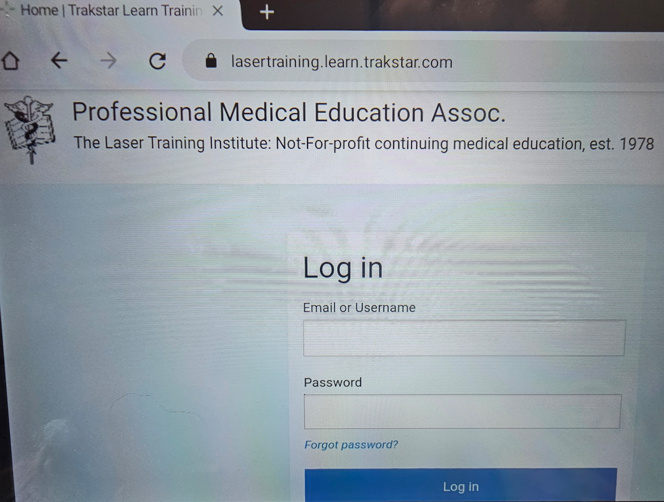
All looks good if this is what you see in the browser. The student can then just open the browser and enter their username and password, which we’ll provide to you just prior to the scheduled exam. They login and it will take them to the start of the exam. As a proctor you should practice this login with a “practice exam” just to experience what they see. We can set you up to try that.
Close the windows you have open and then turn off the device.
To power off the laptop, press and hold the “start” button on left, then choose “power off”.
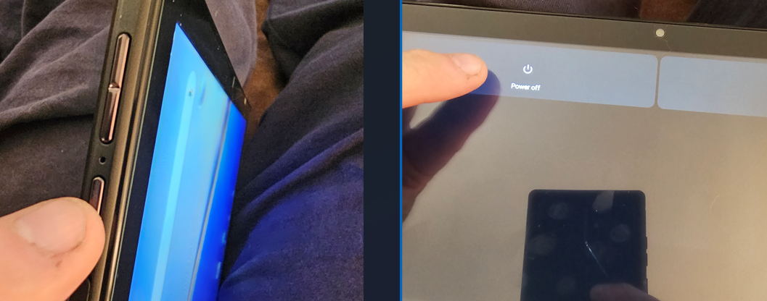

STORAGE, CHARGING AND CARE OF THE DEVICES:
Tablets will come to you in their protective boxes as shown below. We’d recommend storing them in these boxes with the protective film over the screen. Even though we are providing separate charging stations and USB C cables, there is also an individual charger and cable in this box.
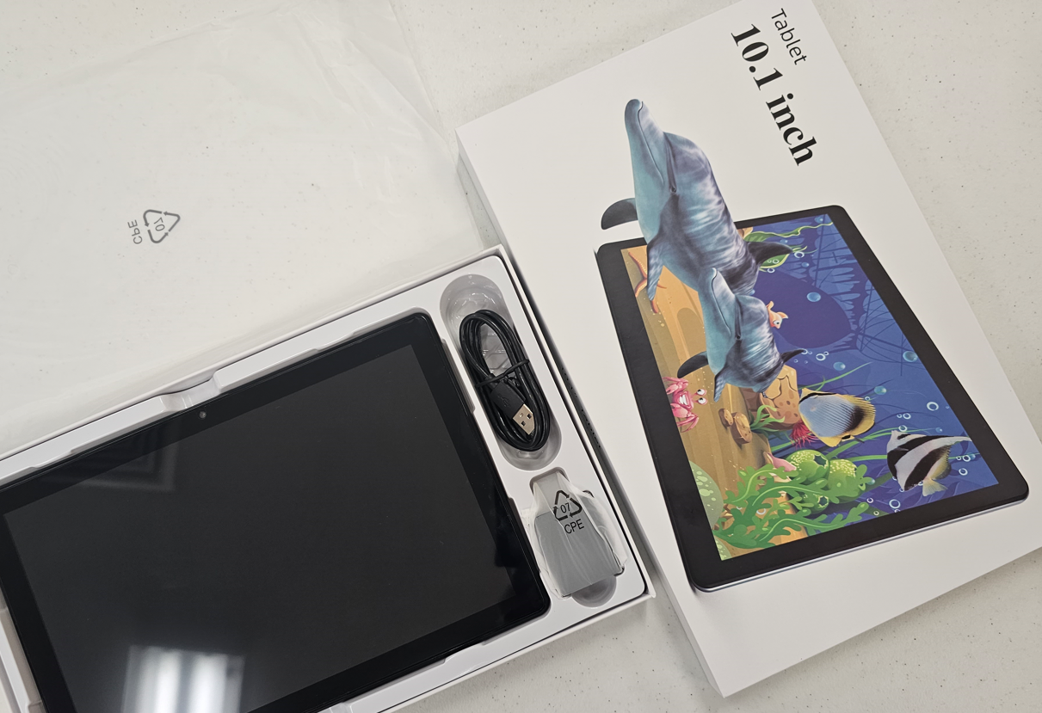
You should clean the tablet screen with something mild like “Windex” using a soft cloth or soft paper towel. Since it’s a touch screen it gets fingerprints all over it so you should clean it after each use. That’s a good idea from both the sanitary aspect and keeping the screen looking presentable.

The devices should be removed from their boxes at least a day in advance of testing and put in the charging station (provided) to ensure that they have a full charge before they start exams. If you don’t have enough slots in your charging station, then each device has its own separate charger.
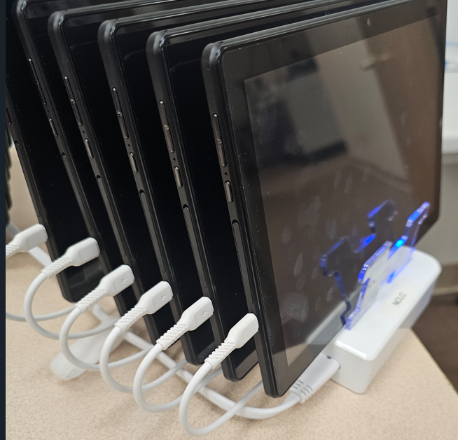
The charging station looks like this with the tablets inserted and charging cables connected:
The station has an on/off switch for charging. Note the plastic separator tabs between the tablets. When you receive them, you’ll have to insert those tabs.
If convenient, you could keep them stored in those stations all the time if you have a secure place for them. We wouldn’t keep the charger on all the time though. Just turn them on prior to use long enough to get a full charge – maybe a day in advance.
We’d also suggest turning them on and opening the browser the day before testing to ensure that it goes to the testing site, and all appears functional.
Unlike the paper exams, these devices have no information stored on them that would require you to keep them secure (except from theft or damage).
When you are ready to setup the tablets for the examination, you may use the tablet stands that are also provided. They fold up so that it props up the tablet at an angle making it easier for the examinee to read and use. The following pictures illustrate their use:
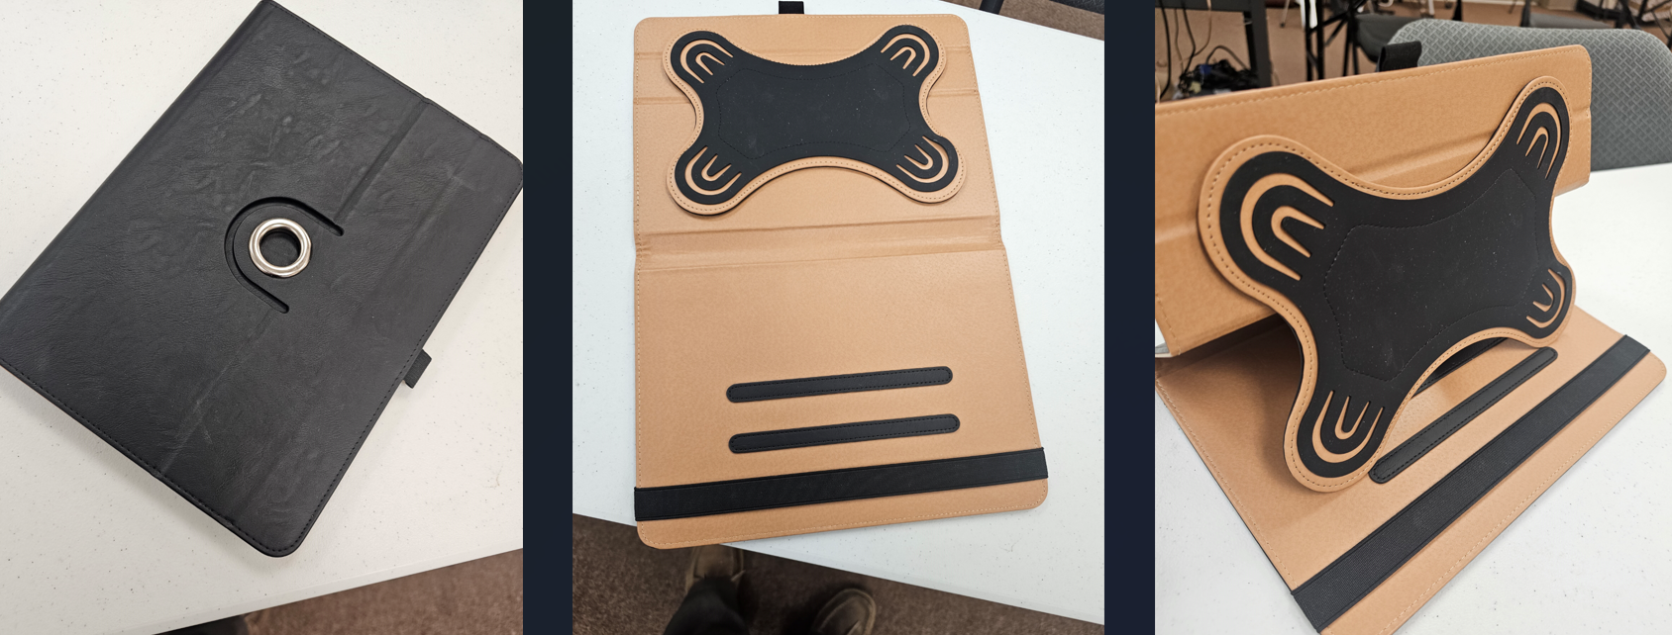
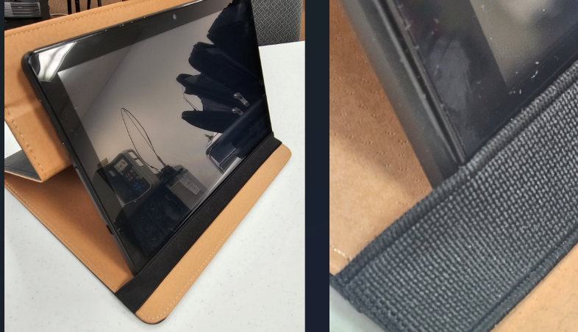
Note the elastic strap at the bottom that helps the tablet stay put on it’s stand. Not necessary but helpful.
When the student has finished testing, they should show you the last screen or two that shows their score and completion of the test. This is insurance against them skipping a question and their score is never recorded. They would return the device to you at that time.
NICE TO KNOW INFORMATION ABOUT STUDENT ACCESS, LOST CONNECTIONS AND BACKUPS:
Once the student completes the online exam, it terminates their access to that exam, so they have no more access to it from another device. In addition, we also “archive” them just after the exam as a double layer of restricted access.
If for some reason they lose their internet connection part way through the exam, then all is not lost. The system will “remember” where they were in the exam and allow them to continue.
In the event that a device “crashes” it would be useful to have a backup device in reserve. It must be a dedicated device that is used for no other purpose. They can resume as soon as they log back in. As a proctor you can give them the extra time for any lost connection time.
In case the device battery dies for some reason, you could use the individual charger that comes in the case to plug it into a power source. Give it a couple minutes to charge up, then restart the device with the charger still attached. They could log back in and finish the exam this way.
In case you lose your overall internet connection, it’s nice to have a second backup ready to go. In our offices we use a Verizon “hotspot” that can connect to 10 devices at one time. In our office we did have an occasion during testing that the entire office lost power. They were able to complete their exams using the battery powered tablets and battery powered hotspot. Backups are up to the individual proctor.
In the event that everything/anything electronic goes down during testing, you can resort to using the paper exams as a backup. They’ll just need to complete them start to finish and you can start their time fresh with the paper exam. We can supply these to proctors to securely hold unopened unless needed in an emergency. They must remain sealed and unopened and handled only by the proctor and stored in a secure location as per the proctor agreement. They will be refreshed periodically with new sealed exams so that we can receive the others back to inspect and ensure that they are all accounted for and unopened. All printed exams are marked in some way to indicate the proctor to which they were sent.
OPTIONAL MAINTENACE OF THE DEVICES:
Once a student has finished their exam, shown you their final score/completion page, and shut down the device, there’s really nothing more you must do (except cleaning) until the next exam session. When the next student restarts the device and reopens the browser, they should get the same login page, without errors, if all works as expected. Sometimes things don’t work like expected. It could be useful for you to clear the cache in the browser between students to help it to remember to come up fresh. Our point of view is that it’s easier to do this proactively after it’s last use rather than try it last minute when a new student starts an exam and has problems.
Since these devices do not have the exams stored on them, it is not necessary for security to ensure that only designated proctors handle and work with them. Any person on your staff may also care for and maintain these devices.
Here are the steps to clear the cache in the browser, to guard against subsequent problems:
You may optionally do this between testing sessions, at your convenience.
Open Browser / Menu at top right / History / Clear Browsing Data / Clear data /
Open Browser / Menu (top right dots or house)
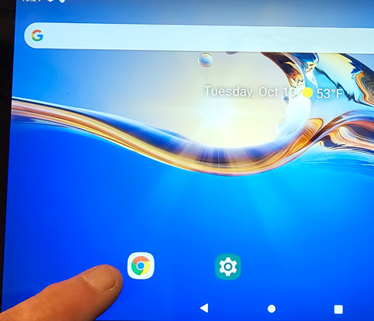
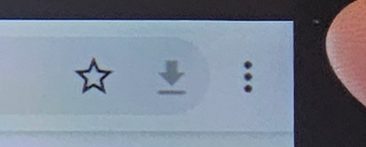
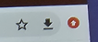
Sometimes the “menu” shows up as 3 dots, or sometimes as the red house icon.

History / Clear Browsing data
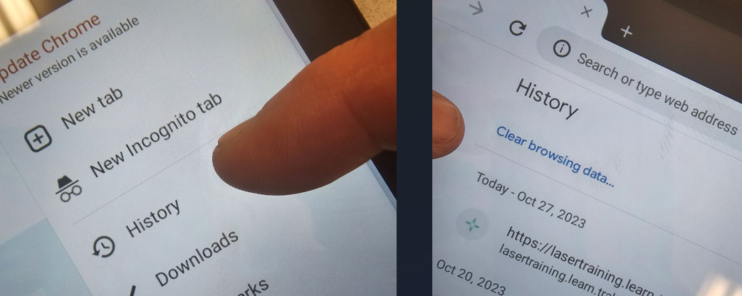
Clear Data (bottom right) / Back Button to return (top left)
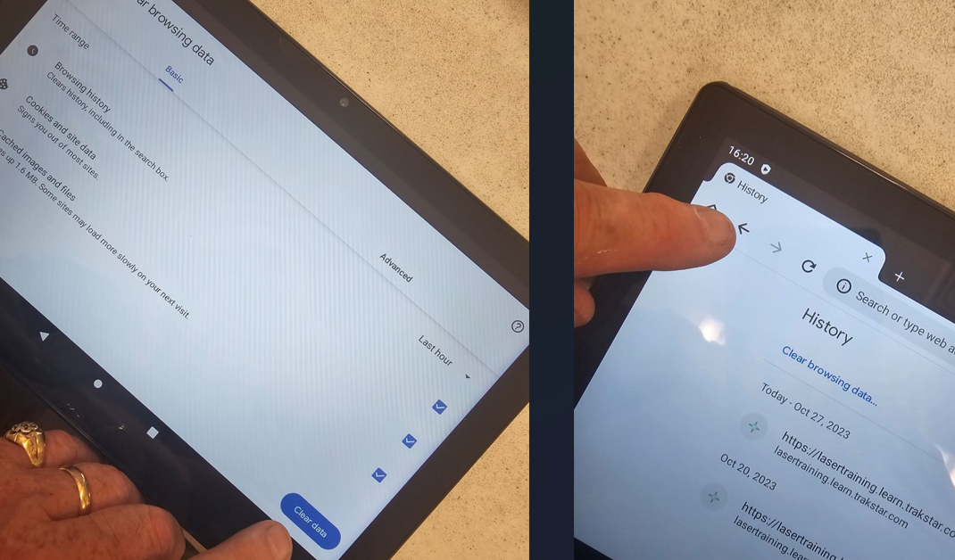
Home Page / - that takes you back to the exam login page:
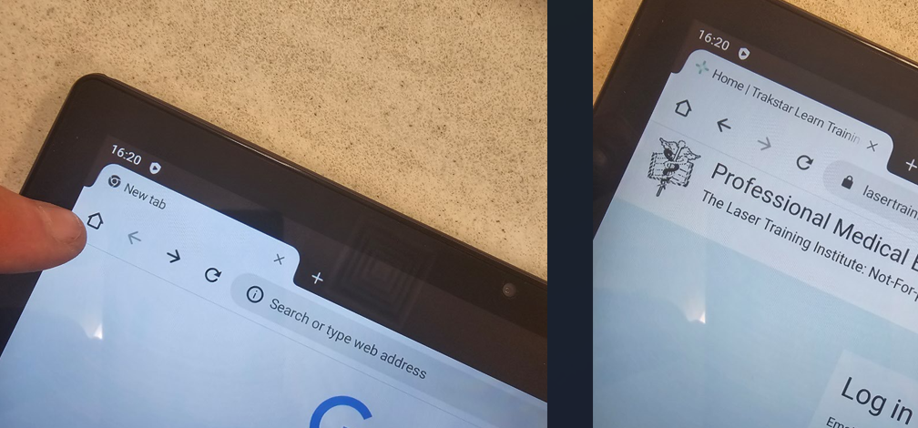
That’s it.
Anomalies that may pop up:
We setup these tablets in the configuration we want for testing. We complete those setups. Essentially we disable all google/emails/popups/reminders/sounds, etc.. That should be the end of it. BUT – sometimes a popup notice comes up when you open the tablet and shows that setup is still in progress and asks you to finish. (No idea of why this happens). You’ll see the following screens. If you click the “finish setup” you get the screen on the right:
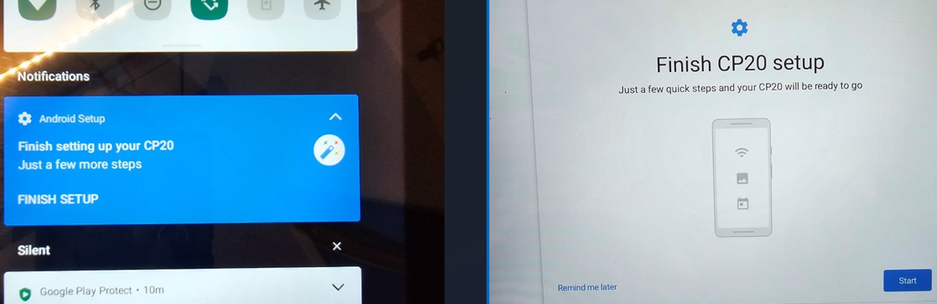
If that happens at the last minute when the student opens it, just hit the “remind me later” at the bottom left of the “Finish CP20 setup”. That will put it off until later and let them proceed. You could do this every time it happens if needed.
If you see this and hit “start”, it will essentially ask you to enable or enter info for many things. You just “skip” them all or decline to enter information and it will work. More information is available in our Proctor Library on the website on how to initially setup and configure these devices – not usually necessary for proctors to know, but there if needed. Call Greg Absten if it becomes a problem.
Most of the time these devices work normally, with no issues.
Further resources for these devices and proctoring the exams are found in the proctor’s library at:
https://lasercertification.org/ProctorLibrary.html

